Amrita School of Engineering, Chennai Campus
AIE
19MEE347 Total Quality Management
Assignment 1

Question 1
Analyse the role of quality dimensions and quality costs in developing an effective Quality Planning framework for a manufacturing organisation. Illustrate how prevention, appraisal, internal failure, and external failure costs influence overall organisational performance.
Answer
Quality planning is the systematic process of identifying customer requirements, defining quality standards, establishing processes, and allocating resources to ensure that products meet the required specifications. In a manufacturing organisation, quality dimensions and quality costs are the two key inputs used to build an effective quality planning framework: dimensions tell the organisation what to plan for, and quality costs tell it how well the plan is working.
1. Role of Quality Dimensions
Quality dimensions represent the different aspects through which customers evaluate the quality of a product. The major dimensions are:
- Performance – The primary operating characteristics of the product. Example: fuel efficiency and engine performance of an automobile.
- Features – Additional characteristics that enhance the product, e.g., safety sensors, infotainment systems, and automatic braking.
- Reliability – The ability of a product to perform consistently without failure for a specified period.
- Conformance – The degree to which the product meets specified design and manufacturing standards.
- Durability – The expected operating life of the product before replacement is required.
- Serviceability – The ease and speed with which the product can be repaired or maintained.
- Aesthetics – Appearance, design, finish, colour, and other sensory characteristics.
- Perceived Quality – The customer's overall perception based on brand image, reputation, and reviews.
These dimensions help an organisation convert customer expectations into measurable quality objectives during quality planning.
2. From Dimensions to a Quality Planning Process
Each dimension identified above feeds directly into a specific quality-planning action, so the organisation is not planning quality in the abstract but against concrete customer-defined criteria:
Quality Dimension Identified | Corresponding Planning Action
Reliability / Durability | Introduce life testing, reliability analysis, preventive maintenance, and statistical process control
Conformance | Define process-control parameters, tolerances, and inspection/testing procedures
Performance / Features | Set product specifications and select suitable raw materials and suppliers
Serviceability | Design maintenance procedures and spare-part availability plans
Aesthetics / Perceived Quality | Set finish, packaging, and brand-consistency standards; monitor customer feedback
In this way, quality planning becomes measurable and objective-driven: it establishes what to inspect, what standard to hold suppliers to, and what data to track — rather than relying on generic “produce a good product” intentions.
3. Quality Costs
Quality costs (Cost of Quality, or COQ) are the costs associated with achieving, maintaining, and correcting product quality. They are generally classified into four categories, and tracking them is what lets an organisation know whether its quality plan is actually working, in financial terms understood by management.
a) Prevention Costs — costs incurred to prevent defects before they occur
- Employee training
- Quality planning
- Supplier evaluation
- Preventive maintenance
- Process capability studies
- Design reviews
- Quality improvement programmes
Although prevention increases expenditure initially, it generally reduces the occurrence of defects and failures over time.
b) Appraisal Costs — costs of measuring and evaluating product and process quality
- Inspection of raw materials
- Product testing
- Laboratory testing
- Calibration of instruments
- Quality audits
- Statistical inspection
Appraisal activities help detect defects before defective products reach the customer.
c) Internal Failure Costs — occur when defects are detected before the product reaches the customer
- Scrap
- Rework
- Re-inspection
- Machine downtime
- Defective material
- Production losses
These costs reduce productivity and increase manufacturing cost.
d) External Failure Costs — occur when defective products reach the customer
- Warranty claims
- Product returns
- Repairs
- Customer complaints
- Product recalls
- Compensation
- Loss of reputation and future sales
External failure costs are particularly damaging because they affect both financial performance and customer confidence, and are usually far more expensive than the prevention costs that could have avoided them.
4. Influence of Quality Costs on Organisational Performance
The relationship between the four quality costs can be represented as a chain:
Prevention → Appraisal → Fewer Defects → Lower Failure Costs → Higher Customer Satisfaction
An organisation that spends appropriately on prevention and process improvement can reduce internal and external failure costs. However, this is a trade-off rather than a one-directional saving: spending too little on prevention/appraisal causes failure costs to dominate, while spending excessively on prevention/appraisal (beyond the point of diminishing returns) raises total cost unnecessarily. The relationship is illustrated below.
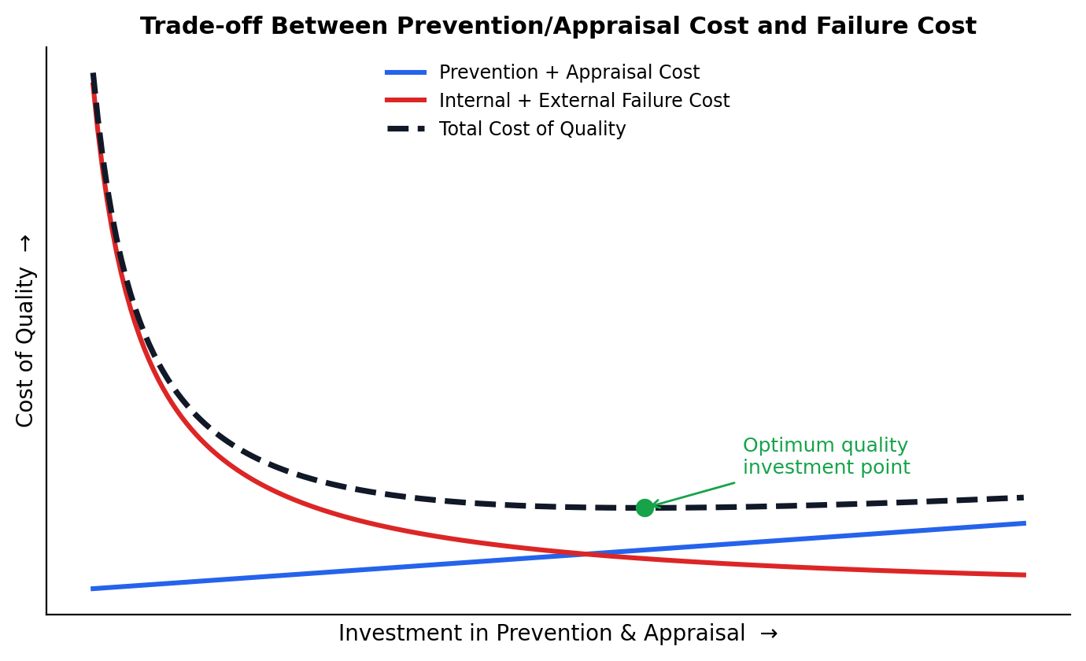
Figure 1: As investment in prevention and appraisal increases, failure costs fall sharply; the total cost of quality is minimised at an optimum investment level, not at zero or maximum spend.
Quality Cost | Main Purpose | Effect on Organisation
Prevention | Avoid defects | Reduces future quality problems
Appraisal | Detect defects | Prevents defective products from progressing
Internal Failure | Correct defects before delivery | Increases production cost and waste
External Failure | Deal with customer-side defects | Damages profit, reputation and customer loyalty
5. Example
Consider an automobile manufacturing company. Investing in employee training, supplier quality management, preventive maintenance, and process control increases prevention costs. However, this reduces defective components, rework, and scrap (internal failure costs). Consequently, warranty claims and customer complaints (external failure costs) also decrease. Many organisations formalise this tracking through a Cost of Quality report reviewed by management, often linked to their ISO 9001 quality management system, so that the financial impact of quality decisions is visible at the strategic level and not just on the shop floor.
Conclusion
An effective Quality Planning framework should not focus only on inspection of finished products. It should incorporate the key quality dimensions from the customer's perspective and emphasise prevention rather than correction. Proper investment in prevention and appraisal — pursued up to, but not beyond, the optimum point — can significantly reduce internal and external failure costs, resulting in lower operating costs, improved productivity, better customer satisfaction, stronger reputation, and improved overall organisational performance.

Question 2
Analyse the factors affecting the successful implementation of Total Quality Management (TQM) in an organisation. Discuss the roles of leadership, quality council, quality statements, strategic planning, and Deming's philosophy, and identify the major barriers that may hinder TQM implementation.
Answer
Total Quality Management (TQM) is an organisation-wide approach to continuous improvement in products, processes, and services with the objective of achieving customer satisfaction. Successful TQM implementation requires commitment from top management as well as participation from every employee. It rests on a small number of interdependent factors, illustrated below, all resting on a foundation of clearly stated organisational quality statements.
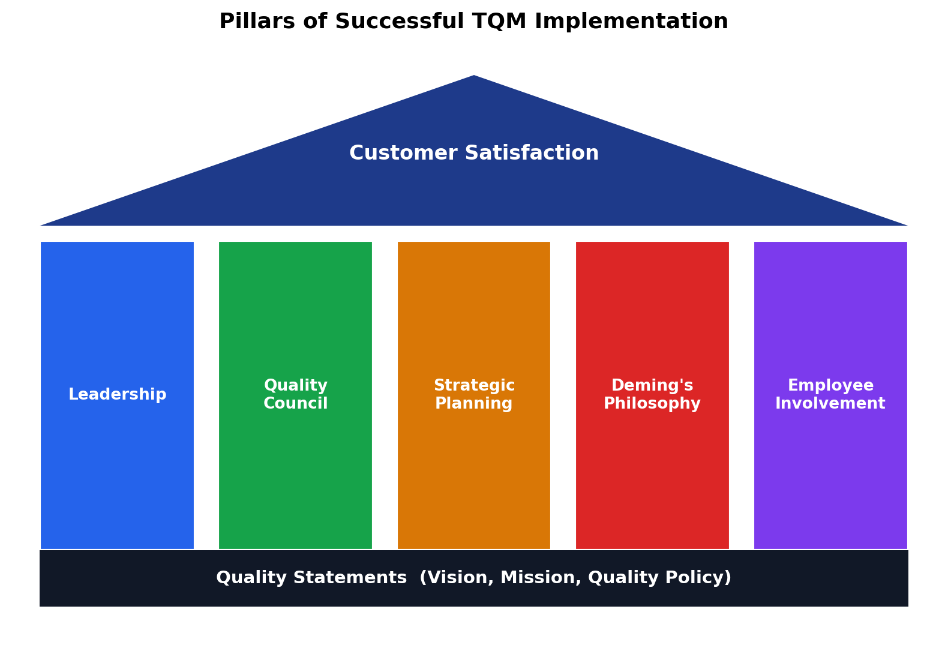
Figure 2: The pillars of TQM implementation stand on a foundation of quality statements and together support the ultimate goal of customer satisfaction.
The major factors influencing successful TQM implementation are discussed below.
1. Leadership Commitment
Leadership is one of the most important factors in TQM implementation. Top management should:
- Establish a clear quality vision
- Provide adequate financial and human resources
- Demonstrate commitment through their actions
- Encourage employee participation
- Establish measurable quality objectives
- Promote continuous improvement
- Create a culture where quality is everyone's responsibility
If management does not actively support TQM, employees are unlikely to treat quality initiatives seriously.
2. Quality Council
A quality council is generally formed by senior managers and key functional representatives to guide and coordinate TQM activities. Its responsibilities include:
- Developing the quality strategy
- Establishing quality objectives
- Identifying improvement priorities
- Coordinating quality improvement teams
- Monitoring quality performance
- Reviewing customer feedback
- Allocating resources for improvement
- Ensuring that TQM activities support organisational goals
The quality council therefore provides direction, coordination, and organisational control for TQM implementation.
3. Quality Statements
Quality statements communicate the organisation's commitment to quality and form the foundation on which every other TQM activity is built. They normally include three linked documents, each serving a distinct purpose:
Statement | Purpose | Typical Content
Vision Statement | Describes what the organisation wants to become in the future | Long-term aspiration, e.g. "to be the most trusted manufacturer in our segment"
Mission Statement | Explains the organisation's purpose, customers, and major activities | Who is served, what is delivered, and how
Quality Policy | States commitment to meeting customer requirements and continuous improvement | Specific, measurable commitments cascaded into departmental objectives
Effective quality statements:
- Provide common direction
- Communicate management's commitment
- Guide employee decision-making
- Establish a quality-oriented culture
- Link day-to-day quality activities with long-term organisational objectives
Without a clearly cascaded quality policy, employees at different levels can end up pursuing inconsistent or even conflicting quality priorities, which is why quality statements sit at the base of the TQM structure rather than being treated as a one-time formality.
4. Strategic Quality Planning
TQM should be integrated into the organisation's strategic planning process rather than treated as a separate quality programme. Strategic quality planning involves:
- Identifying customer requirements
- Analysing the organisation's current performance
- Establishing quality objectives
- Identifying improvement opportunities
- Developing action plans
- Allocating resources
- Measuring results
- Reviewing and continuously improving the plans
Tools such as benchmarking, quality function deployment, Pareto analysis, and statistical process control can support strategic quality improvement.
5. Deming's Philosophy
W. Edwards Deming emphasised that quality should be built into the process rather than achieved through inspection alone. Important principles associated with Deming include:
- Create constancy of purpose for improvement
- Adopt a new philosophy of quality
- Build quality into processes
- Improve continuously
- Provide training and education
- Develop effective leadership
- Remove fear from the workplace
- Break down barriers between departments
- Encourage teamwork
- Eliminate numerical quotas that promote poor quality
- Involve everyone in transformation
Deming also emphasised the PDCA cycle — Plan, Do, Check, Act — as a repeatable method for continuous improvement, shown below. Each pass around the cycle plans a change, implements it on a small scale, checks the results against the objective, and then acts to standardise or adjust before the cycle repeats.
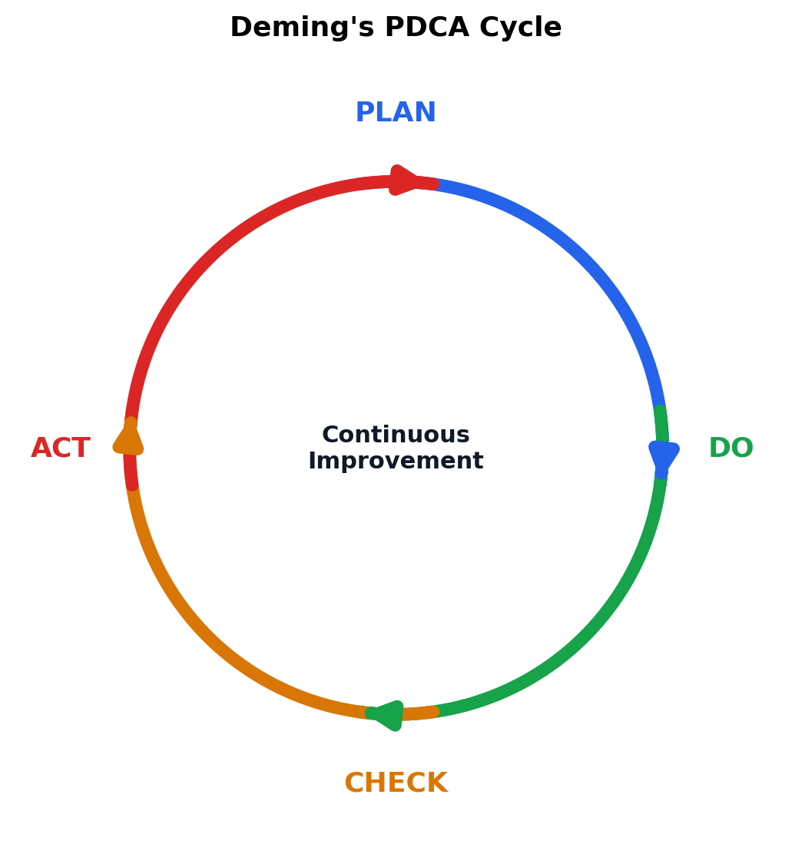
Figure 3: Deming's PDCA cycle — a continuous loop of Plan, Do, Check, and Act.
This philosophy shifts the organisation from a short-term defect-correction approach to long-term process improvement.
6. Employee Involvement and Training
TQM cannot be implemented successfully by management alone. Employees must participate in quality improvement. Organisations should provide:
- Technical training
- Quality awareness programmes
- Problem-solving training
- Team-building activities
- Employee suggestion systems
- Quality circles
Employee involvement improves ownership, motivation, and problem-solving capability.
7. Customer Focus
The ultimate objective of TQM is customer satisfaction. Organisations must identify both explicit and implicit customer requirements and continuously measure customer satisfaction. Customer feedback should be used to improve:
- Product design
- Manufacturing processes
- Delivery
- Service
- Reliability
- After-sales support
Major Barriers to TQM Implementation
Despite its benefits, organisations may face several barriers:
- Lack of Top Management Commitment – if senior management treats TQM as a temporary programme, implementation will fail
- Resistance to Change – employees may resist new processes, responsibilities, measurement systems, or working methods
- Inadequate Training – employees cannot effectively participate in quality improvement without appropriate knowledge and skills
- Poor Communication – lack of communication between management, departments, suppliers, and employees creates confusion and weakens coordination
- Short-Term Focus – organisations concentrating only on immediate profits may avoid investments in training, prevention, technology, and process improvement
- Departmental Barriers – functional departments may work independently rather than as an integrated team, creating problems in cross-functional processes
- Inadequate Resources – insufficient funds, manpower, technology, or time can prevent quality initiatives from being implemented effectively
- Failure to Measure Results – without appropriate quality metrics and performance indicators, management cannot determine whether improvement initiatives are successful
Conclusion
Successful TQM implementation requires strong leadership, an effective quality council, clear and consistently cascaded quality statements, strategic quality planning, employee involvement, customer focus, and continuous improvement based on Deming's philosophy and the PDCA cycle. The major barriers include resistance to change, poor communication, inadequate training and resources, lack of management commitment, and excessive short-term focus. Therefore, TQM should be viewed not as a separate quality programme but as an organisation-wide management philosophy and culture aimed at achieving continuous improvement and long-term customer satisfaction.

